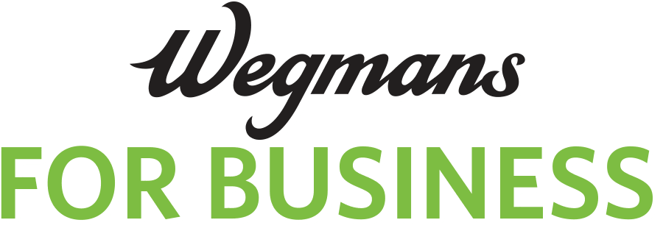

Charge APPLICATION
TO BE USED ONLY BY PUBLIC AGENCIES OR NON-PROFIT ORGANIZATIONS

Must apply for Membership first
Already have a Membership Account? Enter your account #________________________________
RETURN TO: WEGMANS FOR BUSINESS, P.O. BOX 92217, ROCHESTER, NY 14692
OR EMAIL TO: wegmanscharge@wegmans.com
Name of Organization | Approx. Amount of Monthly  Credit Requested (minimum $1,000):
Street Address | City | State | Zip Code
Business Phone | Fax Number |  | Business Email Address
Chief Executive Officer | Email Address
Accounts Payable Director | Email Address
TYPE OF ORGANIZATION (PLEASE CHECK ONE)
( ) College ( ) Hospital ( ) Church ( ) School ( ) Nursing Home ( ) Government Agency ( ) Other/Describe:
Please state primary source and amount of annual funding:
Please list name & address of agency or regulatory authority
Where your annual Financial Report is on file.
If not a public document, please attach a copy of your latest year and financial report.

TERMS AND CONDITIONS – THIS SECTION MUST BE COMPLETED BY ALL APPLICANTS
You represent that all the information you have provided in this application is accurate and that there are no material omissions. You authorize us to make whatever inquiries we deem necessary concerning this application. You further represent that no purchases made on the account will be for personal, family or household purposes. You further represent that the person signing below is authorized to sign agreements on behalf of the applicant. If you are approved for and issued a Charge Card, an Annual Fee of $100 will be charged to the Master Customer Billing Account address on record. The first Annual Fee will be assessed 90 days following the date your Charge Card is approved and issued to you and will be payable in full along with the other charges accrued on your Charge Card account for that month. Thereafter, your Annual Fee will be assessed each year in the same month that your initial Annual Fee is assessed. This Annual Fee is assessed only to the Master Customer Billing Account address on record and does not increase based on the number of accounts maintained or Charge Cards issued for that Master Account. You will be billed on the first business day of each month, at the address we have on record for your account, for all charges made during that month, and you agree to pay all charges on your Charge Card account within 20 days thereafter. If you do not, you will be in default and your account may be frozen if you fail to promptly pay the full account balance due. Also, you agree to pay $20.00 for each check that is returned unpaid. You will pay our costs, including reasonable attorney’s fees, if we have to collect an overdue balance from you. You are responsible for the security of the Charge Card(s) we issue to you and for promptly reviewing your billing statement each month. All charges made with Charge Cards issued to you will be deemed authorized by you up to and including the date you notify us that a Charge Card has been lost or stolen. We reserve the right to limit, cancel, or suspend your right to use your Charge Card(s) at any time for any reason. This agreement cannot be changed except by written notice from us to you, and your use of a Charge Card after being notified of a change indicates your acceptance of the change. You may not assign this agreement except with our express written consent. This agreement is governed by the laws of the State of New York without regard to principles of conflicts of laws. All disputes concerning this account shall be heard in a city, state or Federal court located in Monroe County, New York, and each party hereby consents to the jurisdiction of said courts.

X___________________________________________________________________________________ Signature of Company’s Authorized Representative Printed Name Title Date
For questions call 1-800-934-6267. Visit us at wegmans.com

